Introduction
This tutorial walks you through some of the basic functionality available in Visual Studio. It is intended for ELDP students who do not have any experience with Visual Studio. Its focus is on building a small console based application and showing the student some of the basic IDE capabilities that will be needed to implement the programming assignment that is part of the ELDP course.

Creating the Project
For this tutorial we’ll create a console project. We’re creating a console project because that is what is needed for the programming assignment for the course. Note you’re not limited to a console project for the assignment.

- Start Visual Studio (VS).
- Select the File | New | Project... menu option. The New Project dialog (shown below) will pop up.

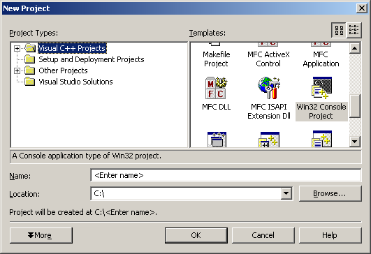

- On the New Project dialog, select “Win32 Console Project” as the project template. Enter “HelloWorld” as the name of the project. Set the location to be ‘C:\’.
- Click on the OK button to create the project. The application wizard dialog will popup. The default settings are fine, so click on the Finish button.

At this point you have a project that contains a HelloWorld.cpp file and the stdafx.h and stdafx.cpp files generated by VS.

Adding Project Specific Files and Code
For a normal HelloWorld example, we could just edit the HelloWorld.cpp file generated by VS. But in order to demonstrate how to add files to your project, we’ll create a class that will actually say “Hello” for us.

- The Solution Explorer pane (probably near the upper right corner of VS) shows you the contents of your project by category. It shows files, resources, and classes. Click on the Solution tab to see the files in the project. Your Solution Explorer should look something like the one below

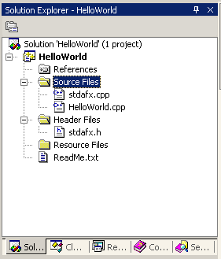

- Right click on the Header Files folder. On the popup menu that appears, select the Add | Add New Item... menu option. The Add New Item dialog will appear.
- On the Add New Item dialog, select ‘Header File (.h)’ as the template. Enter ‘Hello.h’ (without single quotes) in the Name field. Click on the OK button.
- VS added a new file to your project called Hello.h . You should see this file in the Solution Explorer (if you created the file in the wrong group, such as in Source Files, just drag it to the right group). VS has also loaded the file into the editor. The file is empty, so there should be a blank editor ready to use.
- Add the following code in the editor:

#ifndef __HELLO__
#define __HELLO__

class Hello
{
public:

Hello() { }
~Hello() { }

void speak();
};

#endif

- In Solution Explorer, add a file to the Source Files section called Hello.cpp (be sure to select ‘C++ File (.cpp)’ from the file templates). Add the following code to that file

#include "Hello.h"
#include <iostream>

void Hello::speak()
{
std::cout << "Hello World!" << std::endl;
}

- Edit the HelloWorld.cpp file created by VS so it looks like the code below

#include "stdafx.h"
#include "Hello.h"

int _tmain(int argc, _TCHAR* argv[])
{
Hello hello;

hello.speak();

return 0;
}

Building the Application
At this point we’re ready to build the application. To do that, select the Build | Build Solution menu option. The Output tab of your Build window should have the following

------ Build started: Project: HelloWorld, Configuration: Debug Win32 ------

Compiling...
Hello.cpp
HelloWorld.cpp
Generating Code...
Linking...

Build log was saved at "file://c:\HelloWorld\Debug\BuildLog.htm"
HelloWorld - 0 error(s), 0 warning(s)

---------------------- Done ----------------------

Build: 1 succeeded, 0 failed, 0 skipped

To get an idea of what would happen if there was an error in the code, let’s add a syntax error and try the build again. Edit the Hello::speak() method in the Hello.cpp file, removing the ‘;’ at the end of the line that prints “Hello World!”. Then try rebuilding the application.

This time the Task List in the Build window should show the following

error C2143: syntax error : missing ';' before '}'

Double click on the error in the Task List. The editor window will display the file the error is in and move the cursor to the line where the error is. Actually, in this case the cursor is on the line just past the error.

Fix the problem by replacing the ‘;’ and rebuild the application.

Running and Debugging Applications
To run the application select the Debug | Start menu option (or press the F5 key). When you do this a console window will appear, the application will print “Hello World!” and then the console window will disappear. Chances are this will all happen so fast you won’t even see the results of the program.

Although it wasn’t obvious, you program was running in the debugger. We can use that to our advantage. By setting a break point in the debugger, we can have our program stop before it ends. This will give us a chance to see if it worked correctly. To set the break point, double click in the left margin on the line of code you want to stop at. The debugger will stop before this line of code is executed.

For the Hello World program we want to stop just before the main routine returns. Set a break point at the ‘return 0;’ line in HelloWorld.cpp. When you’ve done that, your editor should look like this

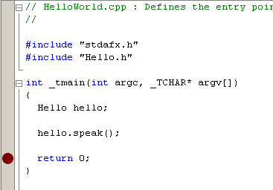

The red dot indicates there is a break point on that line (double clicking on the red dot will remove the break point). Now press F5 to restart the application. The debugger stops at the break point (your editor should look like the image below)

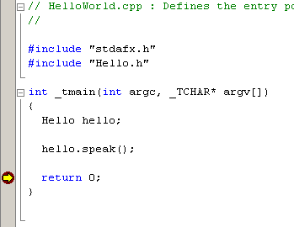

The yellow arrow indicates that the debugger has stopped at that line. You can now look at the console window for your application (you’ll find it on the Windows task bar, not in Visual Studio) to see that the application printed “Hello World!” correctly.

Obviously, this was a very basic application to debug that doesn’t show much of the capabilities of the debugger. In order to get an idea of what we can do with the debugger, edit the Hello.h file so it looks like the file below (bolded code is code you need to add)

#ifndef __HELLO__
#define __HELLO__

class Hello
{
public:

Hello() : m_count(0) { }
~Hello() { }

void speak();

private:

int m_count;
};

#endif

Edit the Hello.cpp file so it looks like the following

#include "Hello.h"
#include <iostream>

void Hello::speak()
{
m_count++;
std::cout << "Hello World! : " << m_count << std::endl;
}

Finally, edit HelloWorld.cpp to look like this

#include "stdafx.h"
#include "Hello.h"

int _tmain(int argc, _TCHAR* argv[])
{
Hello hello;

for (int i = 0; i < 5; i++)
{
hello.speak();
}

return 0;
}

This version of the program will print “Hello World!” 5 times, each time with a number after it.

Set a break point in the debugger at the line in Hello::speak() that increments the m_count attribute. (Your editor should look like the image below)

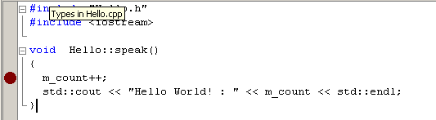

Now start the debugger. The debugger will stop when it gets to the break point. When the debugger is stopped you can examine variables in number of ways. The easiest is to hold the mouse over the variable you want to see. Try holding the mouse over the m_count variable on the line. Some text should popup indicating the value of the variable is 0x00000000.

If you look at the variable window in the lower left corner, you’ll see that it displays the values of two variables. The first variable is m_count, which we already looked at. The second variable is this, which is a pointer to the Hello object that is currently executing. Notice that the this variable can be expanded to show the class attributes (we can again see m_count).

We can also create a watch for variables. Watches show us a variable (or expression) continuously. By using a watch we don’t have to repeatedly move the mouse over the variable we’re interested in. To see how this works, let’s set a watch on the m_count attribute. Select the Debug | QuickWatch... menu option. The QuickWatch dialog will be displayed. On that dialog type “m_count” into the expression field and click on the Add Watch button. The watch window will be displayed in the lower left corner with the m_count attribute in it.

In addition to attributes we can watch expressions. To try this create a new watch and enter “m_count + 100” as the expression. The watch window will constantly evaluate the expression for us.

To see the watches work; we need to step through the program. We can step into a method or we can step over. Step into a method (press the F11 key) when you want to debug the code in a method. Step over a method when you don’t care about the code in that method (note, step over all the built in functions, such as std::cout).

Use the F11 and F10 keys to step through the program (if you accidentally step into a routine you don’t want to be in, press Shift+F11 to get out). As you step through the program take note of the values in the watch window and how they change as the program executes. Notice that when the program is back in the main routine and the m_count attribute is out of scope the watch window reports that it can’t find the m_count symbol.

To resume normal execution of the program press the F5 key.

